NHS Fife Department of Psychology

Understanding
Anxiety

Large Print Version

Help Yourself @ moodcafe.co.uk

What is anxiety?

Anxiety is not an illness that you either have or do not have - everyone has experienced anxiety.

We can all remember stressful times when we have felt anxious, like going for job interview or going to the dentist. That is perfectly normal. But anxiety is a problem when:
- It is experienced frequently or

- If it occurs in situations that should not really be stressful.

When someone is anxious, they experience physical feelings and worrying thoughts. This can make it hard to do even simple tasks and so they begin to avoid things. Often the person does not understand why they feel as they do. When they are relaxed they can see that their worries are over the top, but when the anxiety builds up they feel overwhelmed once again.

The effects of anxiety

Anxiety affects: how we think, what we do and how our body reacts.

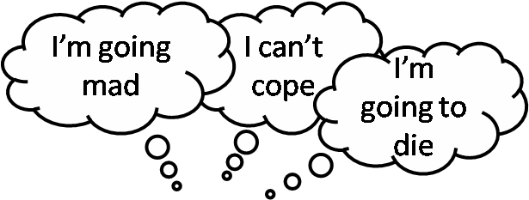

How we think

When anxiety is out of control, people describe having thoughts such as: These thoughts flash automatically into their heads when they are anxious.

Two things should be remembered about automatic thoughts:

- They are irrational and unrealistic – you will not die or go mad

- They end up making you feel more anxious – if you think that you are not going to cope, you will worry even more.

Learning to control such thoughts can help you to handle your anxiety.

What we do

People suffering from anxiety often avoid things, e.g. going out alone or chatting to people. They usually do this because they think that they will cope badly, e.g. they will panic or make a fool of themselves. By avoiding the situation, they feel better. But in the long term avoidance always makes the problem worse. This is because more and more anxiety gets associated with the avoided thing and so it gets harder and harder to face up to it.

Anxiety can also make people feel that they must do certain things e.g. they might start repeatedly checking to see if doors are locked or plugs pulled out, or they might clean the house much more than it needs. Anxiety can also lead to other behaviours such as talking too fast or mixing up words. Being aware of these behaviours can make you feel more anxious.

How out bodies react

There are many physical symptoms of anxiety – such as heart thumping, shaking, sweating, dizziness, breathing difficulties, muscle pain, tiredness, upset stomachs and headaches. The symptoms are very unpleasant and sometimes seem to appear for no reason. People worry that they have a serious physical problem or that something terrible is going to happen. It is important to know that these symptoms are not dangerous and will not do any damage to you even if they are severe.

What causes anxiety?

Our lives and personalities

Some people have had difficult experiences earlier in life and this can make them more likely to get anxious. Other people have always been “the worrying type”. For many

people, anxiety problems begin following a time of stress. E.g. they have difficulties at work or in a relationship, have been bereaved, are in poor health or have money worries. Stress can cause physical changes in the body and make it more likely that anxiety begins.

The body’s reaction to stress – the fight/flight response

In the past our ancestors needed to cope quickly with danger e.g. from wild animals or enemy attack. We still need to cope with danger e.g. to get out of the way of a speeding car. In such situations the body goes “on the alert” ready for action (e.g. heart goes faster and we breathe quicker). But we can also react in the same way to things that worry us, like being criticised. When someone is finding a lot of things worrying, then the body gets into the habit of being “on alert” and physical symptoms of anxiety develop.

What keeps anxiety going?

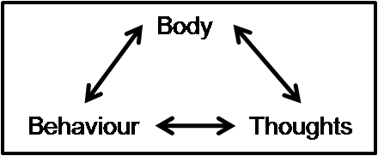You may first notice anxiety in your thoughts, behaviour or body. But your anxiety reaction in each area feeds into the others. This keeps the body “on alert” and creates a vicious circle that keeps the anxiety going.

Anxiety Conditions

Sometimes the effects of anxiety are experienced in a specific way and are recognised as a particular anxiety condition. The most common anxiety conditions are:
- Free floating or generalised anxiety

- Panic attacks

- Phobias including agoraphobia, social phobia, animal phobias and claustrophobia

- Obsessive-compulsive reactions

- Post traumatic stress disorder

People suffering from anxiety will often also experience feelings and symptoms of depression.

Other leaflets, describing the above conditions, are available on moodcafé.

Overcoming anxiety problems

You can learn to manage your anxiety so that it stops being a problem. There are many ways that you can start to tackle anxiety.

Books that can help

Overcoming Anxiety by H Kennerley

Overcoming Loneliness and Making Friends by M Csoti

Overcoming Panic by D Silove

Overcoming Panic, Anxiety & Phobias New Strategies to Free Yourself from Worry and Fear by C Goldman & S Babior
Overcoming Social Anxiety and Shyness by G Butler

These books are also available through the fife book prescription scheme. More information is available at moodcafé - www.moodcafe.co.uk/books-that-can-help.aspx

Self-help leaflets/courses

Living Life is a free telephone service that offers guided self-help. More information is available on the NHS 24 website - www.nhs24.com/UsefulResources/LivingLife There are leaflets that cover other types of anxiety disorders on moodcafé – www.moodcafe.co.uk.
Some organisations offer self-help courses to help individuals to tackle their anxiety: Panic Attacks - www.panic-attacks.co.uk.

Relaxation

Relaxation can help relieve and prevent anxiety.

Relaxation exercises are available to download on moodcafé -

www.moodcafe.co.uk/download-relaxation-exercises.aspx.

A free relaxation CD and booklet are available from Steps for Stress -

www.stepsforstress.org.

Organisations that can help

There are lots of organisations out there that can help. Some have helplines that you can contact to have a chat about your anxiety.
Anxiety UK - www.anxietyuk.org.uk, helpline – 08444 775 774 (Mon-Fri 9:30am-5:30pm) No more panic - www.nomorepanic.co.uk. Includes a forum where you can chat to people who are having similar problems.
For more national helplines and organisations check our moodcafé -

www.moodcafe.co.uk/national-helplines/national-helplines-and-groups-in-fife.aspx.

How to access further help

If you find your anxiety is getting worse, or think you might need further help with your anxiety problems, speak to your GP.

Visit moodcafe.co.uk
for more helpful resources

